

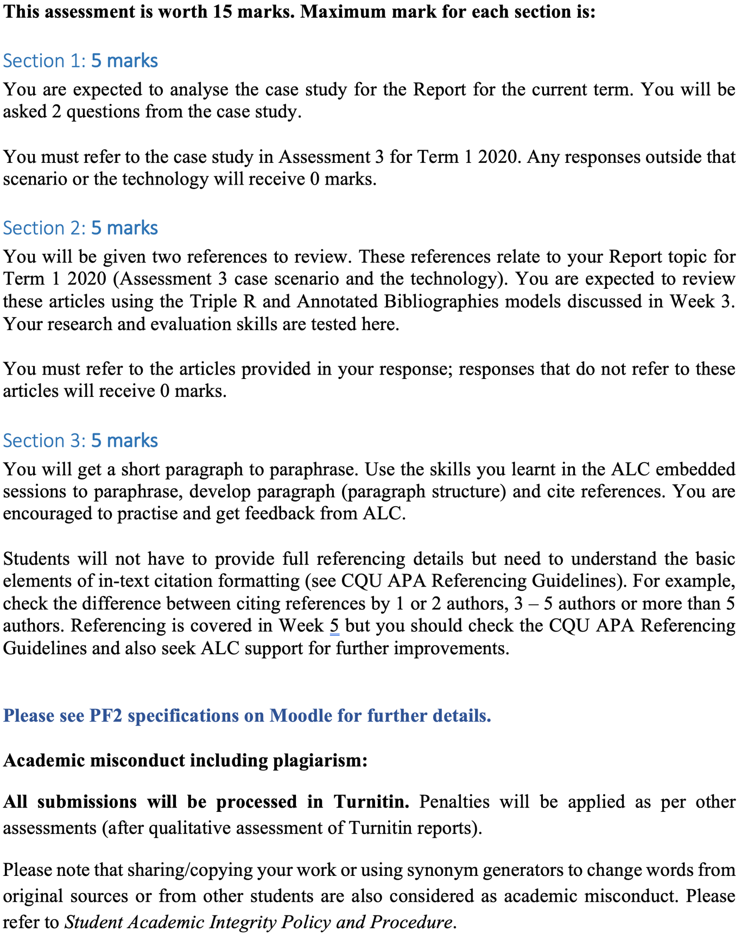

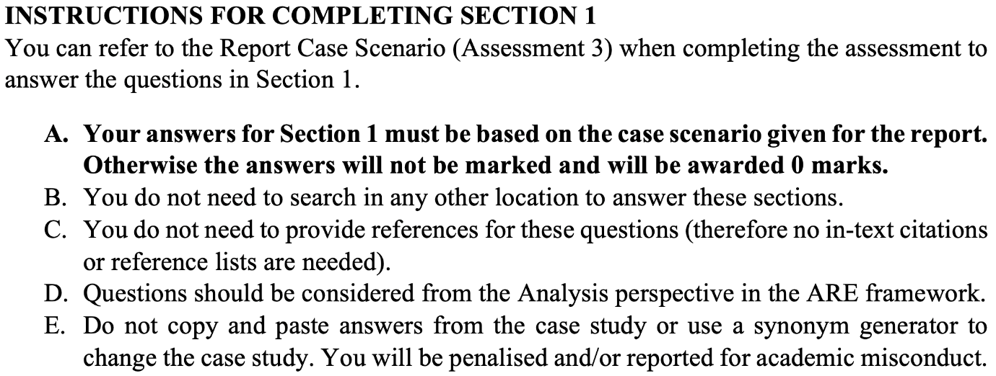

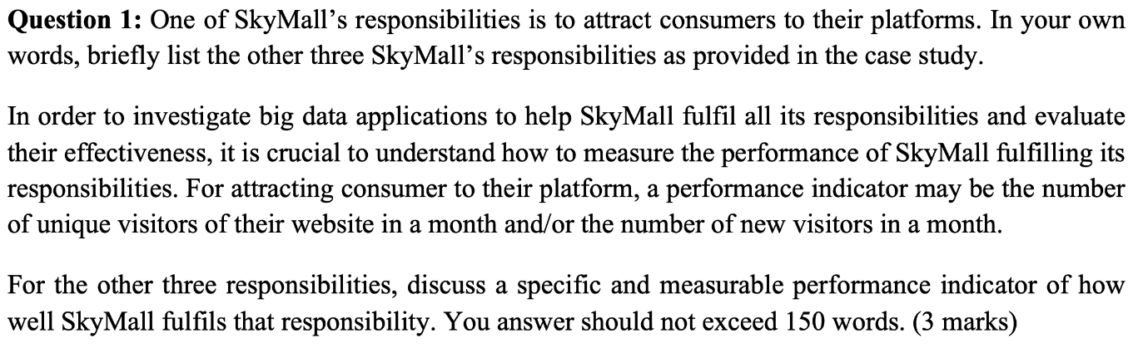
SkyMall’s responsibilities includes:
- With respect to various local legislation make sure market place follow code of conduct and have honest advertisement.
- Hear the complains and responses of customers about the online store and maintain them.
- Maintain and optimize the Order Management task for all online store owners.

Performance indicator:
- SkyMall makes sure that all the items sold from its platform are all genuine and legal, provide honest advertisement of the product on their platform by analysing the comments and reviews of the product and take action if required by sending surveys and acknowledging the action taken by them.
- Also, if the stock of product is less, it has to increase the stock and also make sure that it is not over stocked. If product is less, product delivery can be slow and if more then it increases the expenses for SkyMall.

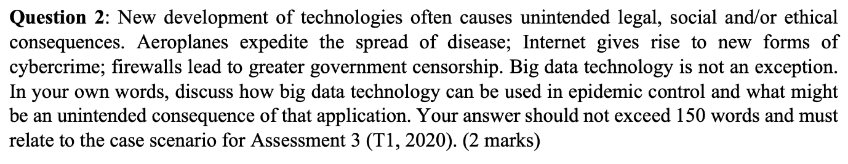

Big data contains every data that has been transmitted through internet. These data can be used for the good purpose as well as evil intention. Each data when connected reveals a pattern and that pattern can be used in epidemic control. User Generated Content (UGC) helps to understand those patterns. If the customers are reduced on a platform, they can collect information for that happening and with big data connects the dots and find possible solution that can increase the traffic in that platform.

Furthermore, if these data are on wrong minds then the damage can be huge. Only if ATM card details are to be leaked from a specific online market place then huge amounts from various banks can go away. So, data from disease control, hospitals can be used know the problems on people health and take necessary action.

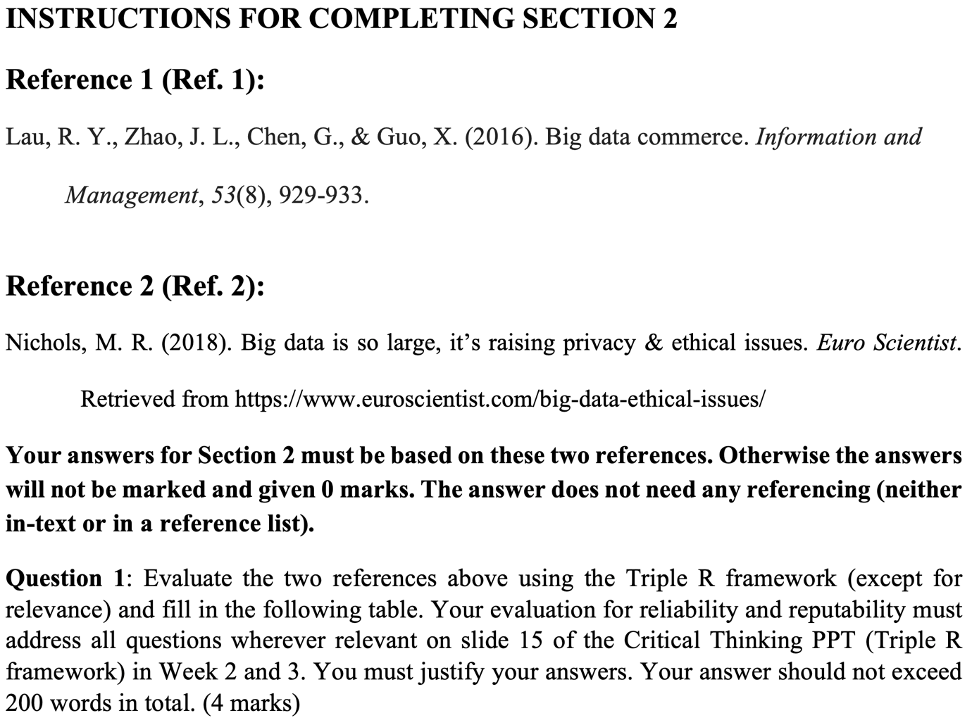
 |  | 

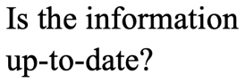 | Yes, published on 2016. | Yes, published on 15 November 2018.
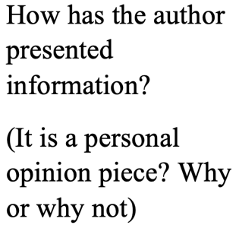 | Author has talked about the characteristics, then comparison and relation and summarised it.  No, it is referencing the past articles and keeping forward the information. | Author talks on big data, its usage, revenue with targeted ads, Apple, Facebook, Google and their role in big data, public interests  Yes, as there is mostly her opinion based on unreliable resources.
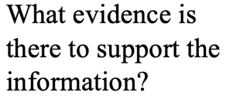 | There are 15 academic references specific on Big Data and from the highly reputable sources including IBM and IEEE. | Cambridge Analytica linked with the BBC news, Google’s Dragonfly Project from “The Intercept” news, Facebook on Brexit and poll interference and Zuckerberg’s call to Washington, D.C.

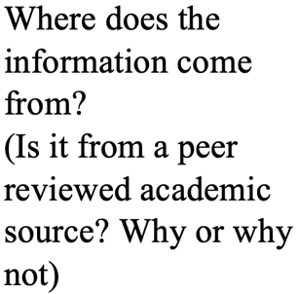 | It is referenced from the past articles written by reputable source and available in Google Scholar.  Yes, because it has been reviewed by 4 individual authors. | The information is from blog post, articles from company and NEWS agency.  No, because it is mostly referenced on blog post and unreliable articles.
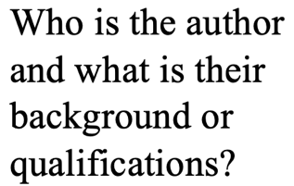 | Raymond Y.K Lau,  J. Leon Zhao,  Department of Information Systems, College of Business, City University of Hong Kong,  Guoqing Chen,  Xunhua Guo,  School of Economics and Management, Tsinghua University | Megan Ray Nichols  Editor of Schooled by Science

Reference 1, as it stays on the main idea Big Data. Also, it is academic with peer review. Theme of Assessment 3 is around definition of Big Data and it explained the concept on Big Data, adoption and its application from State of Art section, ethical issues privacy and social issues from product, people, place, promotion sections.
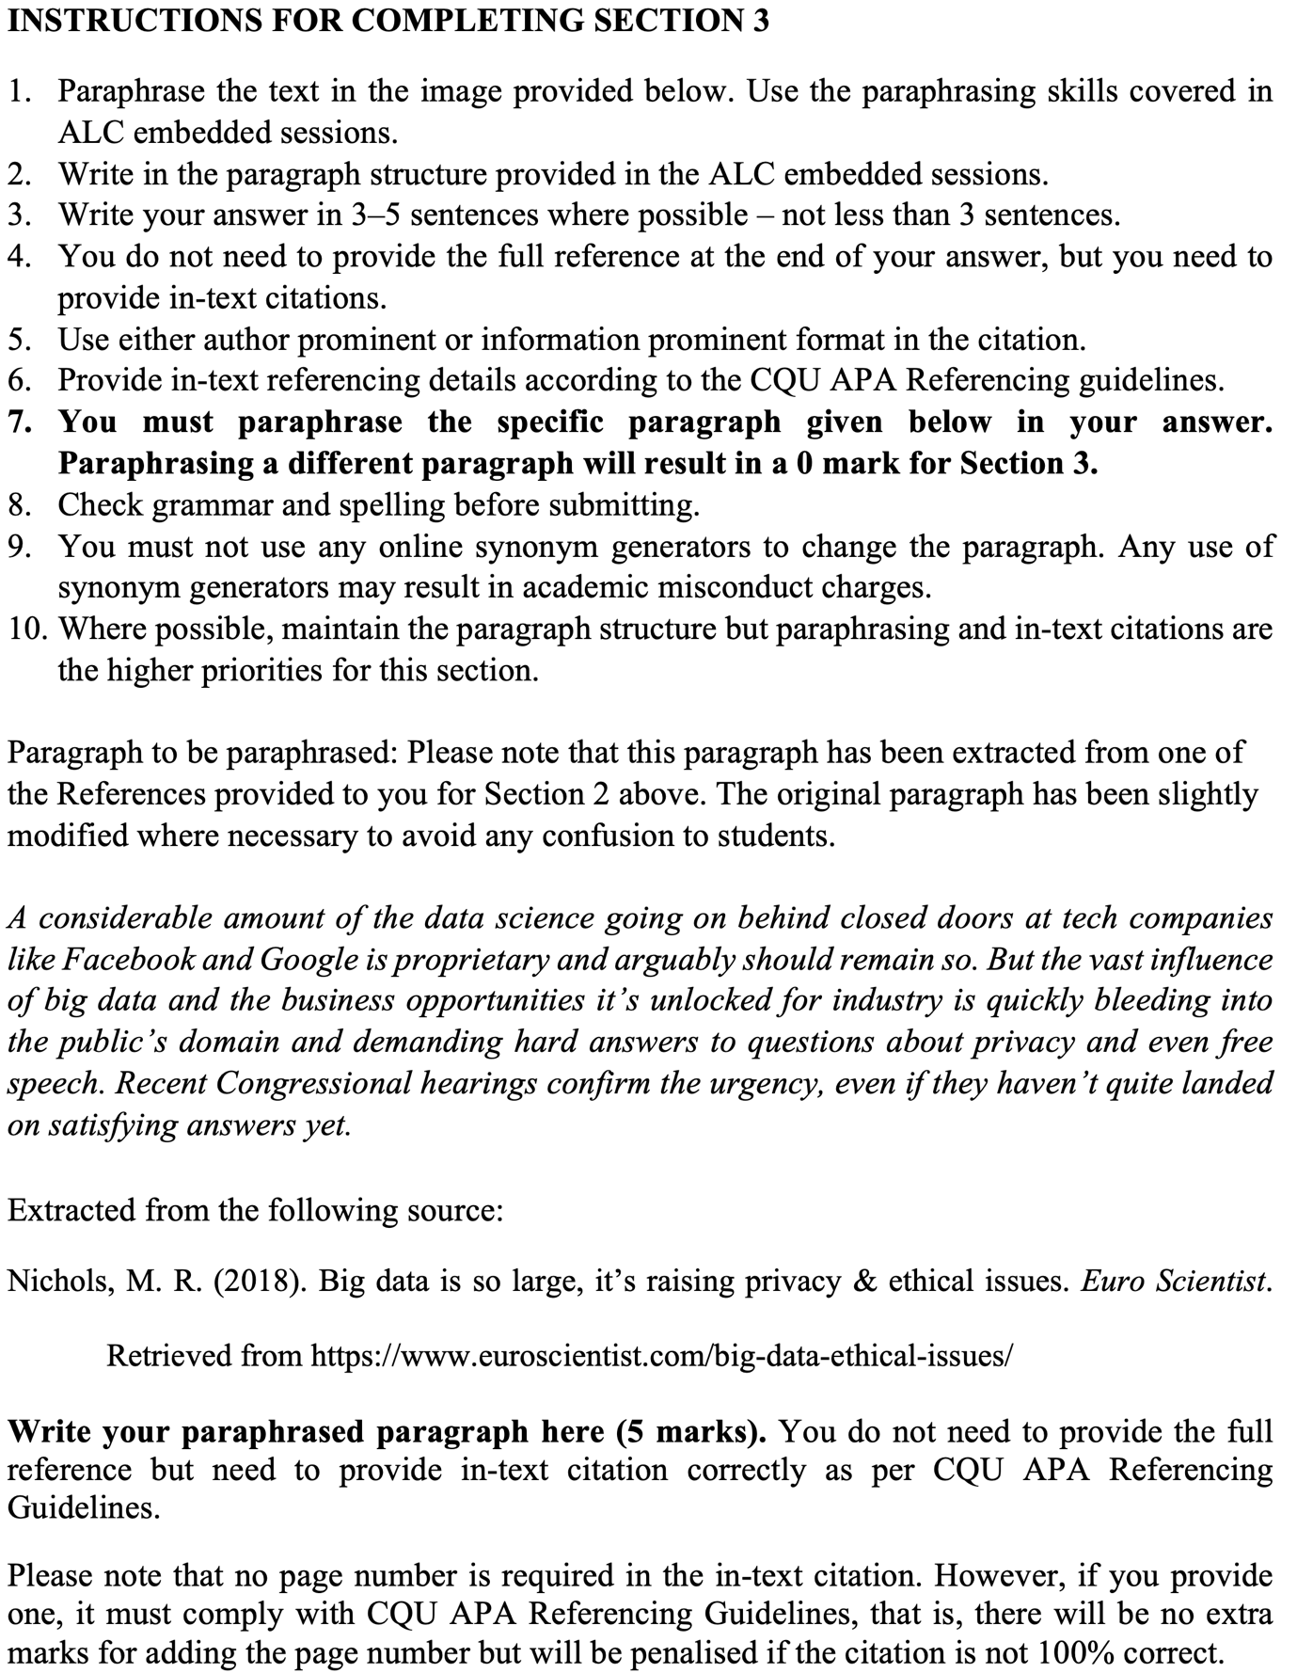

Nichols (2018) assumes Facebook and Google like tech companies, is the owner of big data having huge data science at back-end and should continue that. It has paved the path way for companies with huge business possibilities but also leaking data on public network/server making them questionable about privacy along with right to free speech. Not having agreeable results, despite of hearings from recent Congressional hearings validate the current urgency (Nichols, 2018).

